Car Rental System

# Deliverable#3

* Ahmed Adel 22-101252
* Ahmed Badr 22-101101
* Amr Azazy 22-101237
* Hazem Amer 21-101105

1- System activity diagram (swimlanes)

* (in a separate pdf file due to image quality issue)

2- activity diagrams (swimlanes) for use cases

2)

3)

3-System Sequence Diagram (SSD)

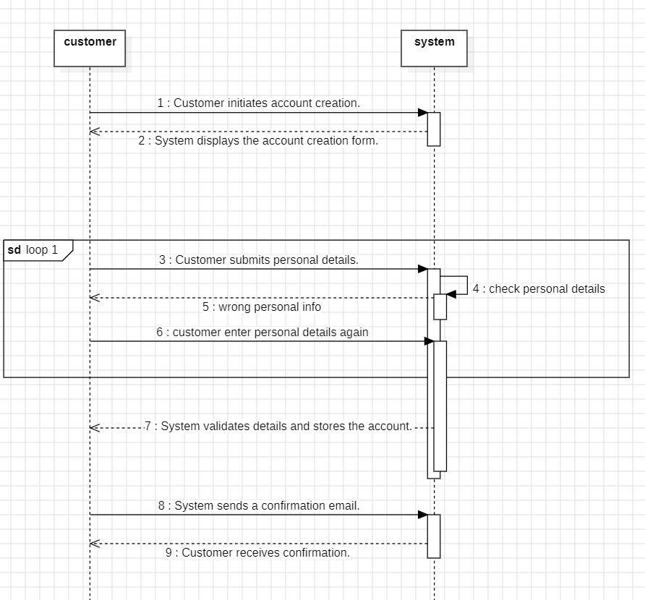

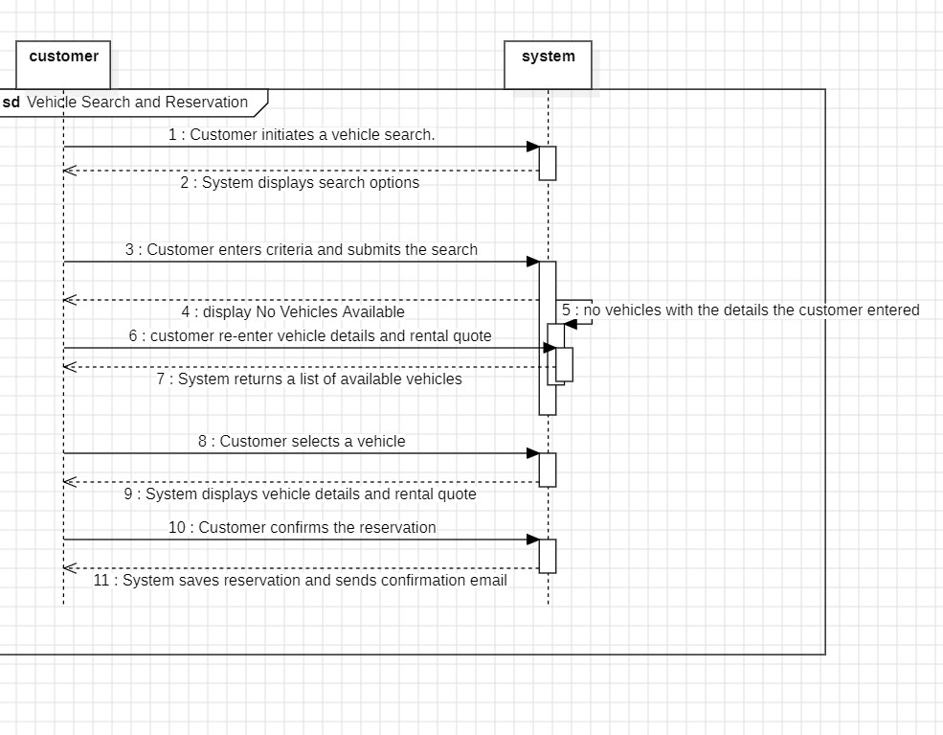

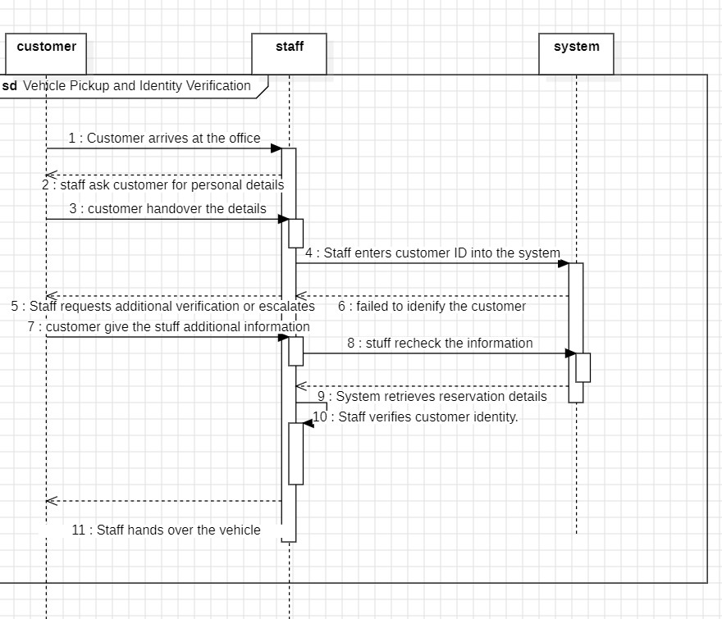

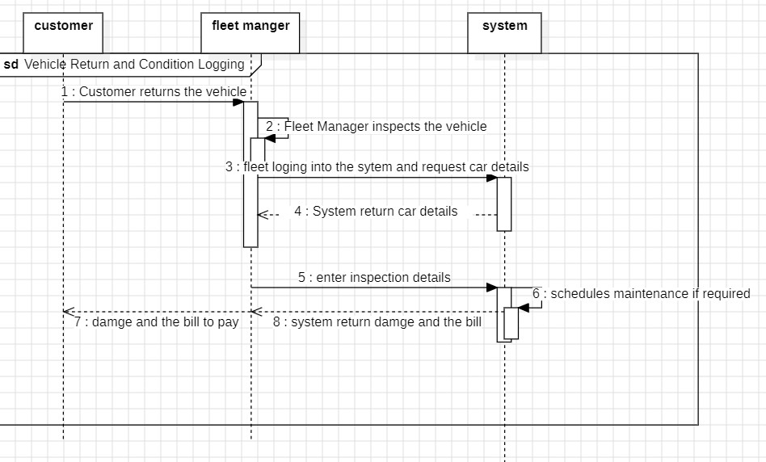

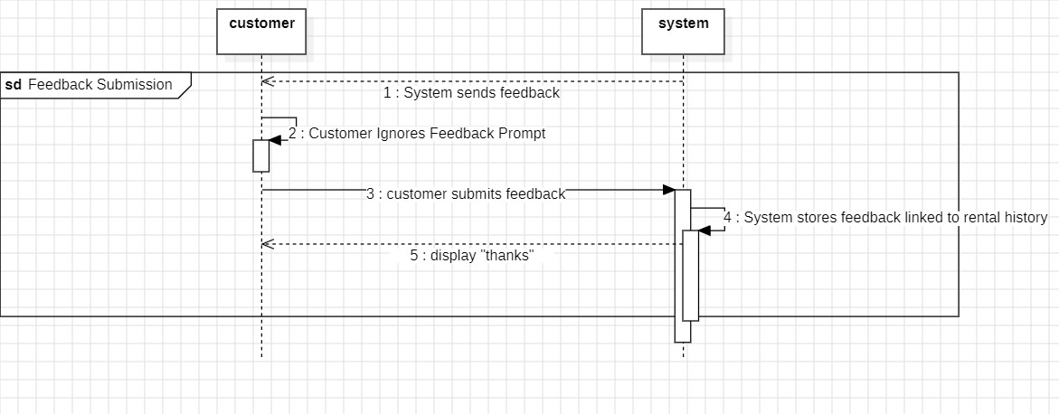

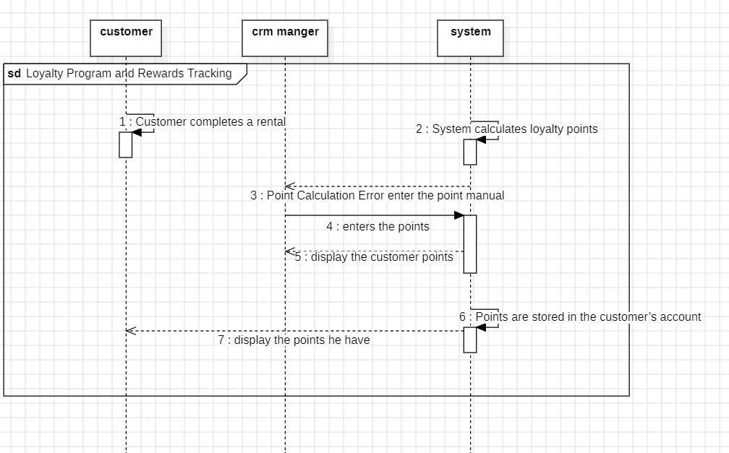

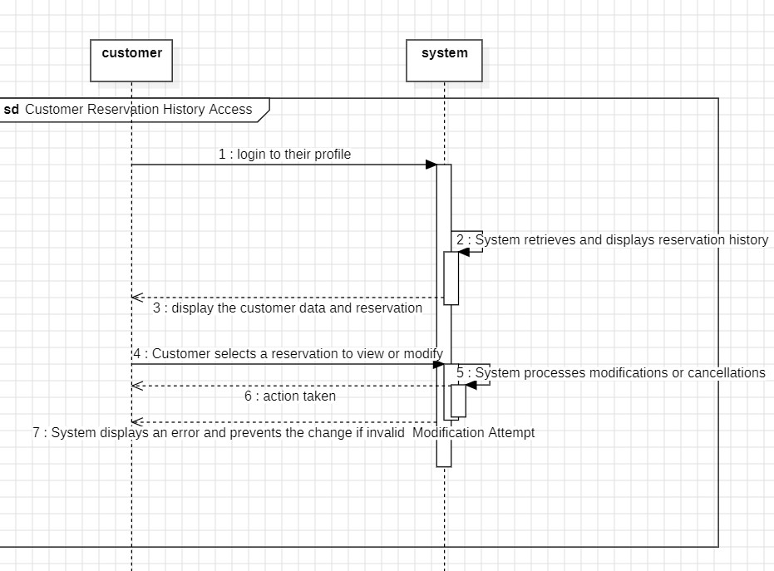

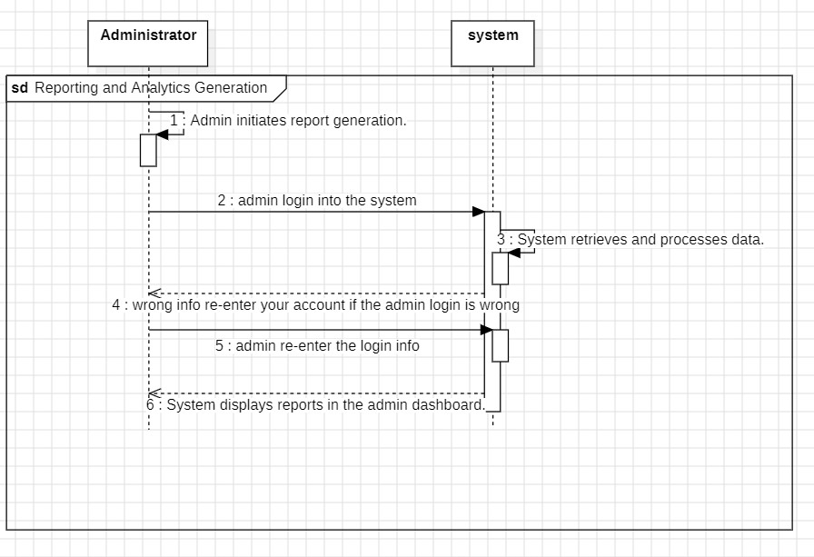

4-state machine diagrams

